LIST OF ETHNOBOTANICALS
We have all the Amazonian products, harvested directly
by our tribes in the deep Amazon of Peru and Brazil
KAMBO
AYAHUASCA
CHACRUNA
CHALIPONGA
SAN PEDRO CACTUS
MAPACHO TOBACCO
RAPE SNUFF (Medicine)
TABACO FOR RAPE
TYPES OF RAPE:
(Rapé: Ocaina, Huitoto, Kaxinawa, Yawanawa, Nukini, Katukina, Matses, Yacuna, Shipibos, Yaguas and more)
SANANGA Liquid
CAAPI EXTRACT MIX 30X
CAAPI EXTRACT PURE 30X
PALO SANTO WOOD
PALO SANTO OIL
ROSE WOOD
ROSE WOOD OIL
YOPO
CAMALONGA
DRAGON’S BLOOD
COPAIBA OIL
BOBINSANA
BRUNFELSIA
COPAL
CHAKAPA
KURIPE
TEPI
GUAYUSA ILEX
AJO SACHA
CHANCAPIEDRA
SUELDA CONSUELDA
GUANABANA
BRUNFELSIA Grandiflora
CHUCHUHUASI
UNCARIA TOMENTOSA
CLAVO HUASCA
HUACAPURANA
7 Roots Wild Mix (7 roots)
And many more products…
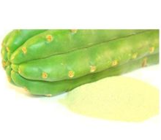
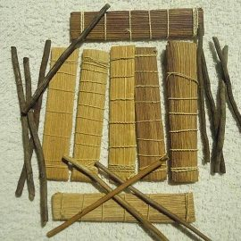
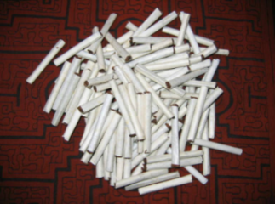
Sacred Products

Kambo Mapacho (tobacco) San Pedro Cactus
Phyllomedusa bicolor Nicotiana Rustica Powder (50g=$45)
(1=$50)(3=$120)(5=$180) (50units=$40)(100units=$70) (100g=$60)(200g=$85)
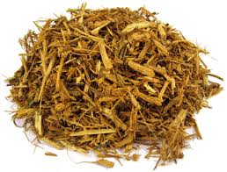
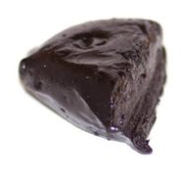
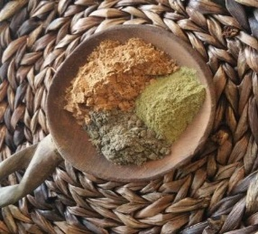

Ayahuasca Mix Strong B. Caapi Mix Paste Ayahuasca Pure
Caapi+Chacruna+Chaliponga 30X of 5 plants (15g=$35) Banisteriopsis caapi
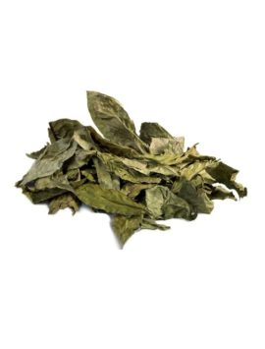
(50g=$45)(100g=$60)(200g=$70) (50g=$55)(100g=$70) (50g=$40)(100g=$60)(200g=70)
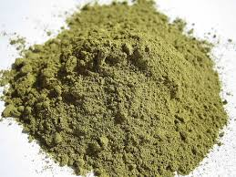

Chacruna Chaliponga Strong B. Caapi Mix Paste 30X
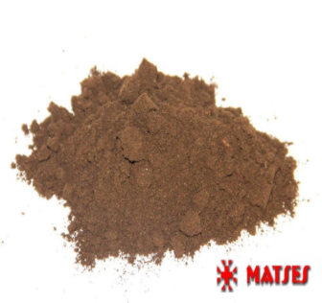
Psychotria viridis Diplopterys cabrerana Caapi+Chacruna+Chaliponga
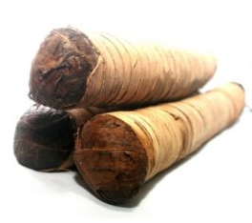
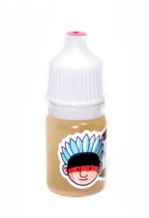
(50g=$40)(100g=$60)(200g=$70) (50g=$40)(100g=$60)(200g=$70) (15g=$35)(50g=$55)(100g=$70)

Sananga liquid Mapacho Uncut Roll (1=1kg) Rapé (Snuff)
Tabernaemontana undulata Tobacco-Nicotiana rustica (of 3,4,5,7,10 plants)
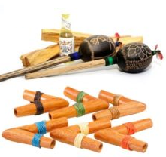
(15ml=$35)(30ml=$50)(60ml=$70) (500g=$60)(1kg=$80)(2kg=$130) (10g=$28)(30g=$60)(100g=$100)
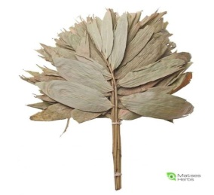
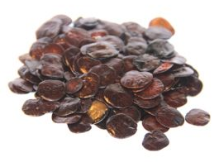

Yopo (Seeds) Chakapa Native Art
Anadenanthera Peregrina Ceremony Ayahuasca Kuripes, Tepis, Rattles,
(25g=$30)(50g=$40)(100g=$50) (1=$40)(2=$69)(3=$89) Pipes, Camalonga and more

The prices are with shipping included
If you want more discounts, or need a larger / smaller amount, Contact us
If you are looking for a product and cannot find, "We have it for you”
Shipping worldwide with tracking number l Estimated time of arrival is 10 - 15 days
Shipping method: Priority mail l Payment methods: Western Union – Paypal
www.matsesherbs.com
Contact Us: matsesherbs@gmail.com l hamerfox18@gmail.com
Fair Trade: Supporting our Amazonian tribes and indigenous artists is part of MatsesHerbs.com,
Join us for the best natural products....
SHIPPING TRACKING: WWW.17TRACK.NET
Amazon Loreto - Acre Am i Peru - Brazil

